Experiment 24:

Aim:

To establish Control of Fan, Light, Window & Application of Using Cisco Packet Tracer.

Procedure:

Step 1: Take the devices switch, Router, Server, Laptop and give connections for the devices. And then give Ip address for the following devices.

Step 2: Later add IOT smart homes and then the devices(fan, light, window)connected with the router. After give the Ip address for following connections.

Step 3: After the wireless connections can connect with home way process and then it passes with the router. Then every IOT smart homes are formed in the way with wireless connections and then it connects with router.

Step 4: We can give the username and password to process the connections. After we can apply the username and password in the monitor, we can get the options to on the connections.

Step 5: After giving the connections the given smart homes are start working with the router.

Step 1: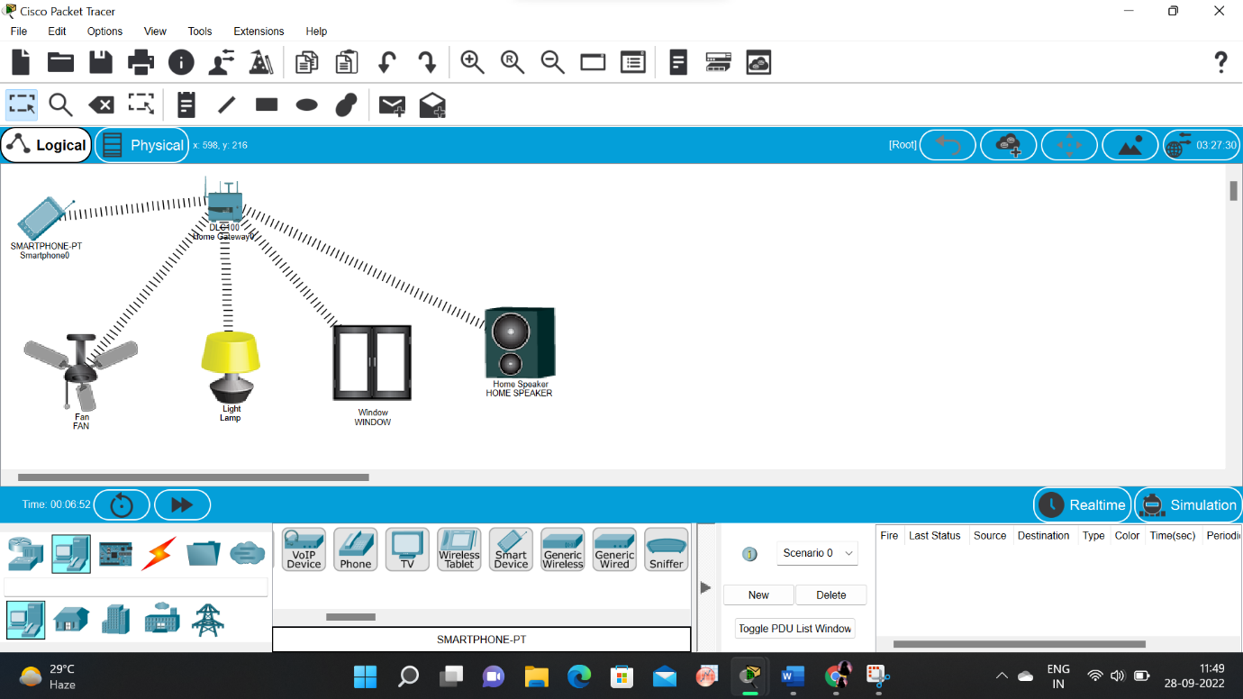

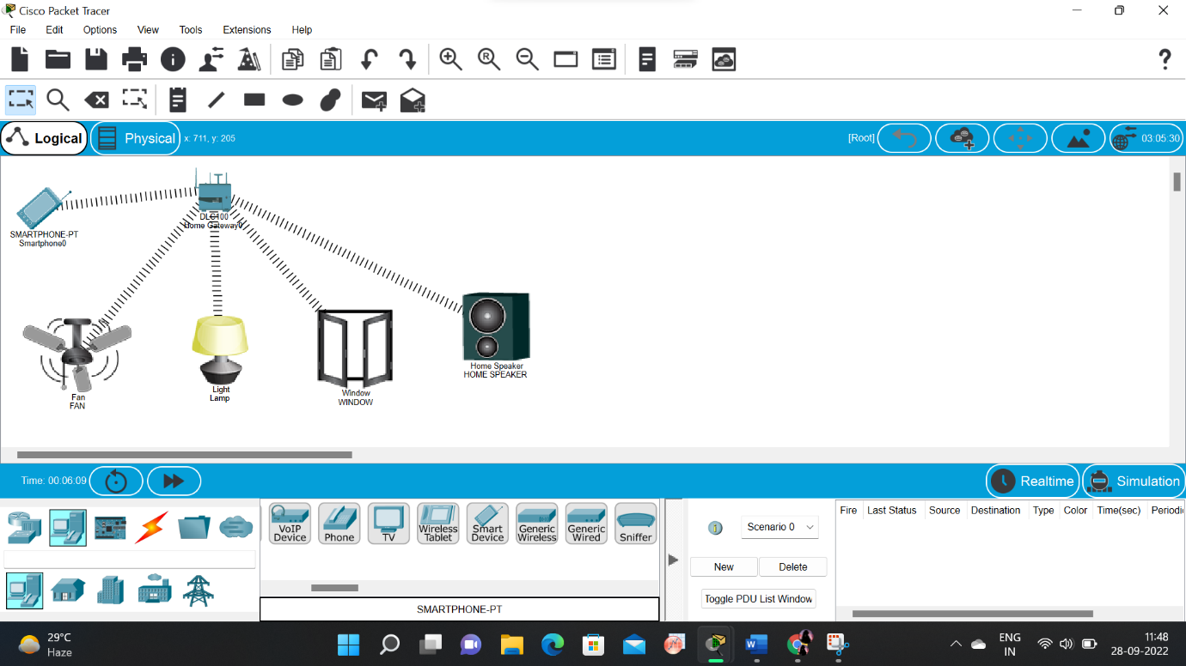Step 2:

Result:

To establish Control of Fan, Light, Window & Application of Using Cisco Packet